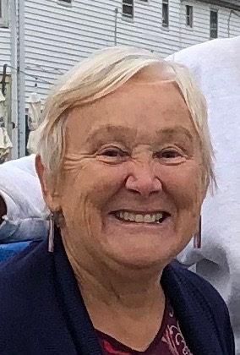

Shelley Mitchell

Secretary

Shelley Mitchell moved to Humboldt County to attend HSU in 1970 and forgot to leave when she graduated. In 2016, she finally got tired of the fog and moved to Palm Desert. She has had a long career working in nonprofit and human services agencies in a variety of capacities. She has also served on the boards of several nonprofit organizations.

In 1999 Shelley began a nonprofit consulting business. She worked with numerous organizations to bring millions of dollars in grant funding to organizations in Humboldt County and throughout California. She teaches grant proposal writing for a variety of local and statewide organizations.

